Design and Implementation of a Secure Cloud-Based Digital Locker System
Siya Mehta
Bsc IT
12308033
Lovely Professional University Phagwara, Punjab

Abstract—This paper describes the creation and implementation of our secure document management solution deployed in a cloud environment. Our team created the proposed system as a mobile application with Android platform with coding made in Kotlin and XML which we are presenting to our users as a useful method for working with digital documents such as PDF files and image documents. User login is facilitated using Firebase Authentication whereas Firebase Realtime Database allows us to insert document metadata that consists of document names, URLs and user IDs. As a document hosting service, we have integrated Cloudinary which also helps us generate sharable links to our documents. In addition, we have also created a very intuitive interface that allows our users the feature of easy and quick uploading, searching and sharing of the documents. As per the results obtained from our research, we conclude that our proposed system works well on Android phones when judged with respect to its efficiency in document storage, search and access capabilities. Furthermore, we see that our proposed system helped us eliminate the necessity of physical document management along with facilitating document access.
Keywords—Digital Locker, Cloud Storage, Android, Firebase, Document Management, Security.

INTRODUCTION
In the digital era today, there are many challenges in managing important documents. The conventional method involves using physical documents which are usually inefficient, consume much time, and subject to various dangers. For instance, physical documents may get lost, damaged, or accessed by unauthorized persons. In response to these challenges, digital methods such as mobile technology and cloud computing have been introduced as effective alternatives for efficient and secure document management.
A Document Management System (DMS) provides a mechanism where users can manage important documents efficiently and securely. It encompasses functions such as document storage, organization, retrieval, sharing, among others. Moreover, cloud-based DMS systems also incorporate benefits such as remote accessibility and data synchronization. Therefore, the use of cloud-based DMS makes it easy for users to access their documents without relying on physical storage media. However, data security and user authentication are major concerns in cloud-based DMS applications.
This paper presents an overview of the design and implementation of a secure digital locker mobile application built using cloud technology. The suggested application uses Firebase authentication to implement user logging and management, Firebase Realtime Database to store document metadata information, and Cloudinary for the actual storage of the document and link generation. Users can upload PDF documents or images, view them, and share them via generated links.
The aim of this study is to design and implement a cloud-based secure document management system that would help people handle their files in an efficient manner. Thus, combining cloud computing techniques with mobile application development, this solution proves to be both user-friendly and effective when it comes to digital document management.
Accessibility and convenience in using systems are not the only requirements that should be considered during the design and development process. Data integrity, privacy, as well as the effective and fast retrieving of information are important as well. In this regard, the ever-increasing amount of data requires the development of efficient means that will allow organizing the information in order to make it easily accessible. Thus, the usage of mobile apps becomes relevant since smartphones have become the primary devices for most users around the globe.
Cloud infrastructure can become a solid foundation for the efficient work of a document manager app. It allows storing the data reliably and provides an opportunity for the automatic backing up and synchronization of data, which is especially useful in cases when multiple devices are connected simultaneously. Besides, due to authentication, the security of data in cloud storage can be ensured as well. All these technologies together become a powerful platform that helps manage documents efficiently.
This paper shows how cloud infrastructure and mobile technologies may be used to develop an efficient document manager application.

LITERATURE REVIEW
Document Management Systems have seen tremendous improvement with the development of cloud computing and mobility technology. There are many document management systems that have been created to solve problems with security of document storage and effective sharing of documents. This section describes some existing solutions and points out both advantages and disadvantages of each platform.
Classical DMS were mainly based on local storage which had certain restrictions such as poor accessibility or threats related to the loss of information or dependency on local hardware. Due to cloud storage options, applications like Google Drive and Dropbox become very popular among users as they give remote access, synchronization, and ability to share any digital document. They also demonstrate scalability and intuitiveness although they cannot provide customizability and document structuring for certain needs.
As far as Backend-as-a-service platforms are concerned, they provide all necessary tools needed to create applications of different kinds. In particular, Firebase helps to create applications with instant data synchronization, which makes Firebase Realtime Database very useful in such cases. It does not allow, however, to manage big files effectively and requires additional work with storage services.
The cloud-based media management applications, such as Cloudinary, can be commonly used in order to store and serve media files. They allow for fast uploading, delivery, and access through URL generation. Even though all these options seem to be quite good, a platform such as Cloudinary requires appropriate configuration and integration with other back-end services.
As shown in Table 1 existing systems revealed that although many of them have a number of useful features, either security-related or usability-related, there is still a lack of a combination of both security and usability with cloud storage into one mobile application. In order to fill this gap, the suggested digital locker solution is going to be based on the integration of mobile app development and cloud-based authentication and file storage systems.

System | Technology Used | Advantages | Limitations
Google Drive | Cloud Storage | Easy access, sharing | Limited customization
Dropbox | Cloud Storage | Sync across devices | Security concerns
Firebase | Backend Service | Real-time sync, authentication | Not ideal for large files
Cloudinary | Media Storage | Fast delivery, scalable | Requires integration
Table 1: Analysis of Document Management Platforms

METHODOLOGY
The designed solution for the proposed Digital Locker system involves developing it as an Android application, which incorporates cloud computing capabilities for storing and managing digital documents. The methodology will entail incorporating various cloud computing tools and concepts in order to ensure user authentication and management of data.
The first step towards developing the app will involve designing an easy-to-use UI by using XML layouts in Android Studio, with its logic being handled by Kotlin programming language. The second phase will see the incorporation of Firebase authentication in order to enable user registration and login capabilities.
Users who have successfully been authenticated will then be allowed to upload various types of documents from their devices. The selected documents will then be uploaded to Cloudinary by processing them in the app first. Cloudinary is a cloud-based service provider of media storage.
On completion of uploading, the document meta information such as filename, file url, user id, and time stamp is stored in Firebase Realtime Database for effective data management and synchronization. In this case, the application extracts and presents the data on the UI dynamically using a RecyclerView.
Further, the system is capable of opening documents using relevant intents as well as sharing document file link among other users. Integration of Firebase and Cloudinary has made the system scalable, reliable, and performant.
For smooth operation of the system, asynchronous calls are made while uploading files and downloading data, which avoids freezing of the application. Error handling is included throughout the process, such as selecting files, uploading, and querying databases, in order to give proper feedback to the user in case of any error occurred. The application ensures that each document has its own unique user id to have data isolation from other users. Real-time listeners are used in this application, where new data will automatically add to the document list from the Firebase Realtime Database.
As a result, users do not require refreshing the data manually, and always view the latest data. Efficient memory management is also practiced while using images and documents. This avoids application crashes and ensures application stability. It can be concluded that the method used is efficient enough to implement this application practically.

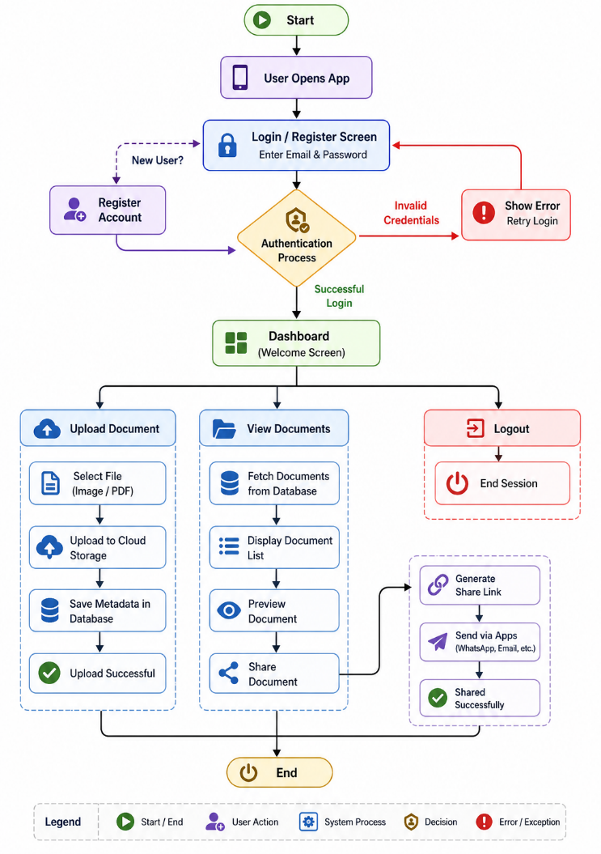
Figure 1: Workflow of the Citizen Digital Locker Application
The Digital Locker App we have is a secure and efficient platform for your digital document management via a structured workflow. At app launch the user is taken to the login or registration page. New to the app? We have sign up feature for you, existing users may log in with email and password to continue. The system will check your info should what you entered be incorrect you will get an error message and asked to try again. Upon successful authentication you will be granted access to the main dashboard which is the control panel of the app.
The first three main actions that a user can take using the dashboard are document uploading, viewing stored documents, and logging out. In the document uploading section, the user can select a file, which can either be a picture or a PDF file, and uploads it into the cloud storage server. At the same time, critical information such as the file name, time when it was uploaded, and user identity will be saved in the database. After the upload process is completed, the system will inform the user about its success.
In the document management section, the user can see all documents that he/she has uploaded earlier. The program will retrieve the information about these files from the database and display it in a list form. The user can see each document and use the sharing function, if necessary. By clicking on this icon, a unique link will be generated, which allows the user to share his/her document through other platforms such as emails or instant messaging apps.
Finally, the user can end his/her session by clicking on the log out option.

RESULTS
The designed application of the Digital Locker has been created and tested effectively on Android mobiles. The software proved itself highly stable when performing all tasks related to the document upload, storage, search, and distribution. Firebase Authentication has been used to ensure safe user authentication and registration, thus securing private data from any kind of breach.
While testing, all types of documents, including PDF files, have been easily uploaded to Cloudinary without any significant delays. The generated secure URL addresses were perfectly saved within the Firebase Realtime Database. This solution provided fast and effective management of the data. Moreover, synchronization was carried out effectively, which meant that any uploaded documents became instantly visible in the main application window. The usage of RecyclerView contributed greatly to improving its performance.
Moreover, the software proved to be very effective in terms of accessing documents using Android intents, whereby users were able to open files from applications installed on their systems. In addition, the capability for sharing document links through messaging applications, email services, and other applications was very efficient.
Also, it demonstrated excellent levels of responsiveness and usability owing to its well-designed user interface. This enabled effective interaction with the application despite uploading numerous documents. The application maintained data consistency even while uploading multiple files. It worked consistently, except for the occasional requirement of internet connectivity, which had minimal effects on its performance.
As such, the entire system succeeded in meeting its main goal of providing an efficient and safe means of document management through the use of cloud technology and mobile applications.

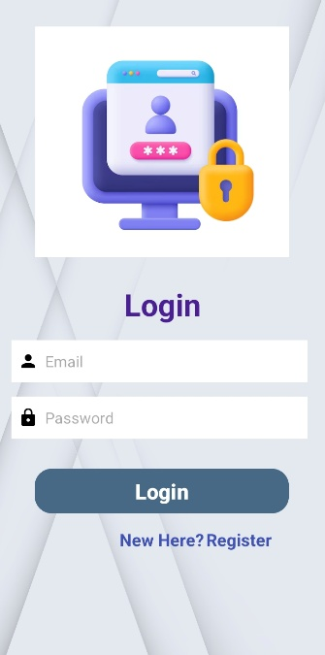
Figure 2: User Login Interface
The at login we present to users a secure way into the Digital Locker system which they do so by putting in their registered email and password. We have integrated it with Firebase Authentication which we use to verify user info and thus secure access. Also we have included a sign up option for new users which we think improves the system’s ease of use and accessibility.

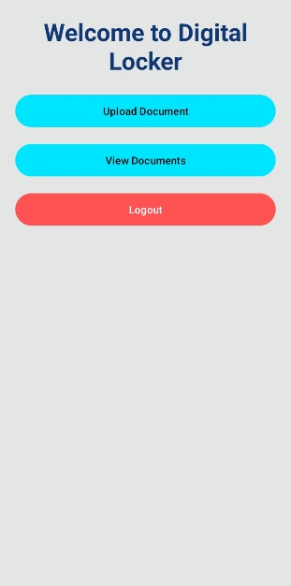
Figure 3: Dashboard Interface of Digital Locker
The interface of the Digital Locker Application that consists of the dashboard facilitates all interactions with the users. From Figure 3, it is evident that the screen contains three main options: upload document, view stored documents and log out from the system. The interface is quite simple and allows users to navigate through the app easily and without difficulties.
Upload Document allows the user to pick and upload various types of files like images or PDFs to the cloud storage. "View Documents" takes the user to the page with the list of files that have been uploaded earlier, which makes the process of accessing and sharing of documents convenient. "Logout" is designed to prevent any possible unauthorized access and provide security to the session.
In addition, the layout of the interface is clear and the buttons are placed in such way that improves navigation. Moreover, the system reacts to the users' actions and navigates to the required activity instantly, thus making the process easy. Overall, the dashboard helps to integrate all important functionalities into one place.
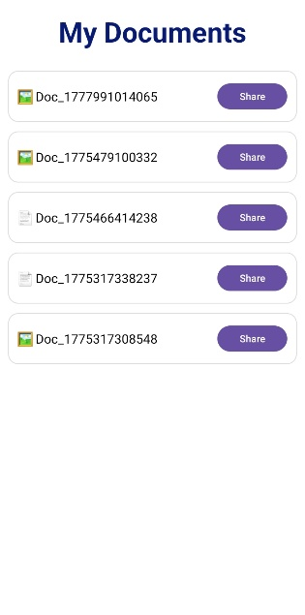
Figure 4: Document List Interface
This display shows what set of documents each user has uploaded. We present each document by its name and also a icon which represents its type (image or PDF). Also we have included a share option for each file which in turn gives the user easy access to share document links. The data is fetched dynamically from the Firebase Realtime Database and we update in real time which means that any newly uploaded document will immediately appear.

CONCLUSION
In this paper, a reliable and efficient Digital Locker has been developed and deployed using Android app development along with cloud computing. This system uses Firebase authentication, Firebase database, and Cloudinary in order to ensure the security of users' data and efficient storage.
Among other features, document upload, real-time database synchronization, document viewing, and document sharing have been incorporated into the software in order to perform a wide range of document management activities. The use of cloud services allows providing scalability and easy access to the uploaded files from anywhere and at any time.
As seen from the results, the application is able to effectively handle documents while being simple enough and user-friendly. Thus, using the latest advancements in mobile apps and cloud computing, the developers were able to come up with an efficient way of organizing digital documents.
This research proves the importance of creating applications based on modern technologies that can effectively address problems associated with the use of outdated technologies. Moreover, this system may be further expanded into more complex solutions.
The proposed system can become the basis for developing more advanced enterprise-level solutions in the future.

FUTURE SCOPE
However, apart from its efficient performance in storing and handling documents, several aspects should be improved in order to optimize the work and enhance user experience. First of all, there could be a number of improvements regarding the system's security, such as introducing more sophisticated ways of ensuring safety of personal data, including biometric (fingerprint or face recognition) and encryption technologies.
The other way of enhancing the application is to add some useful features. For instance, the system could use OCR technologies to enable extracting and searching through the text embedded in documents. Also, users could benefit from categorizing and tagging function. Finally, it might be reasonable to enable offline access to downloaded earlier documents, so that users could view them even without Internet connection.
It might also be a good idea to develop a web application of the product, which would allow for accessing files from desktop computers and tablets and, thus, providing users with additional flexibility. Finally, it might be necessary to introduce some artificial intelligence approaches into the system, like intelligent document categorization.

REFERENCES
[1]. Banjade, S. (2026). Towards a Unified Civic Identity Stack: Integrating Nepal's National Identity Card (NID) with Cross-Domain Government Services. SSRN. https://ssrn.com/abstract=6392278.
[2]. Cieśla, M. (2023). Perceived Importance and Quality Attributes of Automated Parcel Locker Services in Urban Areas. Smart Cities, 6(5), 2661–2680. https://doi.org/10.3390/smartcities6050120.
[3]. Kumar, P. 2024. "Digital Governance and Public Participation: Assessing the Impact of E-Government Initiatives in India.".
[4].Chandrakar, P. (2026). Digital Identity Convergence and Electoral–Administrative Efficiency
in India. International Research Journal of Education and Technology, 9(3), 1635–1645.
[5]. Liu, S., Malhotra, A., & Hassini, E. (2026). A parcel locker sharing system to enhance accessibility an equity. Journal of Transport Geography, 130, 104504. https://doi.org/10.1016/j.jtrangeo.2025.104504.
[6]. Meleiro, Tomás Albuquerque. Smart Lockers in a New E-commerce Era: CTT's Expansion in the Spanish Market Through Strategic M&A. 2024. NOVA - School of Business and Economics, Master’s Project.
[7]. Dhiman, T., & Madan, P. (2025). Transforming Governance through Digital Public Infrastructure: A Case Study of Apuni Sarkar Portal in Uttarakhand (India). Journal of International Commercial Law and Technology,…6(1),..823–835. https://doi.org/10.55041/ijsrem40719.
[8]. Dhiman, T., & Madan, P. (2025). From Vision to Reality: How Digital Public Infrastructure is Shaping Service Delivery. Journal of Marketing & Social Research, 2(5). https://jmsr-online.com/
[9]. J. C. Scott. Seeing Like a State: How Certain Schemes to Improve the Human Condition Have Failed. Yale University Press, 1998.
[10]. Keen, C.C.; Liang, C.H.; Sham, R. The effectiveness of parcel locker that affects the delivery
options among online shoppers in Kuala Lumpur, Malaysia. Int. J. Logist. Syst. Manag. 2022, 41, 485–502.
[11]. Drèze, J., Khera, R., & others (2017). Aadhaar and welfare: Evidence from India. Economic & Political Weekly, 52(50).
[12]. Siddique, W., Naeem, M., & Khan, A. (2012). From governance to e-governance: A way forward. International Journal of Scientific Research in Engineering and Management. https://doi.org/10.55041/ijsrem30103.
[13]. Kamble, R. R., Suriya, A. Y., & Kishor, S. B. (2025). Improving rural e-governance in India: Challenges, strategies, and a proposed framework. Global Journal of Innovation Research, 2(5). https://doi.org/10.59613/global.v2i5.171.
[14]. Dahan, M., & Gelb, A. (2015). The Role of Digital Identification in the Post-2015,Development Agenda. CGD Working Paper.
[15]. Kapur, D. (2019). Aadhaar and the politics of welfare reform in India. India Review, 18(3), 1–22.

al of Education and Technology, 9(3), 1635–1645.
[5]. Liu, S., Malhotra, A., & Hassini, E. (2026). A parcel locker sharing system to enhance accessibility an equity. Journal of Transport Geography, 130, 104504. https://doi.org/10.1016/j.jtrangeo.2025.104504.
[6]. Meleiro, Tomás Albuquerque. Smart Lockers in a New E-commerce Era: CTT's Expansion in the Spanish Market Through Strategic M&A. 2024. NOVA - School of Business and Economics, Master’s Project.
[7]. Dhiman, T., & Madan, P. (2025). Transforming Governance through Digital Public Infrastructure: A Case Study of Apuni Sarkar Portal in Uttarakhand (India). Journal of International Commercial Law and Technology,…6(1),..823–835. https://doi.org/10.55041/ijsrem40719.
[8]. Dhiman, T., & Madan, P. (2025). From Vision to Reality: How Digital Public Infrastructure is Shaping Service Delivery. Journal of Marketing & Social Research, 2(5). https://jmsr-online.com/
[9]. J. C. Scott. Seeing Like a State: How Certain Schemes to Improve the Human Condition Have Failed. Yale University Press, 1998.
[10]. Keen, C.C.; Liang, C.H.; Sham, R. The effectiveness of parcel locker that affects the delivery options among online shoppers in Kuala Lumpur, Malaysia. Int. J. Logist. Syst. Manag. 2022, 41, 485–502.
[11]. Drèze, J., Khera, R., & others (2017). Aadhaar and welfare: Evidence from India. Economic & Political Weekly, 52(50).
[12]. Siddique, W., Naeem, M., & Khan, A. (2012). From governance to e-governance: A way forward. International Journal of Scientific Research in Engineering and Management. https://doi.org/10.55041/ijsrem30103.
[13]. Kamble, R. R., Suriya, A. Y., & Kishor, S. B. (2025). Improving rural e-governance in India: Challenges, strategies, and a proposed framework. Global Journal of Innovation Research, 2(5). https://doi.org/10.59613/global.v2i5.171.
[14]. Dahan, M., & Gelb, A. (2015). The Role of Digital Identification in the Post-2015,Development Agenda. CGD Working Paper.
[15]. Kapur, D. (2019). Aadhaar and the politics of welfare reform in India. India Review, 18(3), 1–22.

